Virtual Channel (VC) and Virtual Path (VP) in ATM Networks
In ATM (Asynchronous Transfer Mode) networks, data is transmitted in small, fixed-size cells of 53 bytes. ATM uses two important concepts to organize the movement of cells through the network: Virtual Channel (VC) and Virtual Path (VP).

Virtual Channel (VC)
A Virtual Channel (VC) is a logical connection between two ATM endpoints used to carry cells belonging to a particular communication.
For example, when a computer communicates with a server through an ATM network, a virtual channel can be established for that communication.
- Each VC is identified by a Virtual Channel Identifier (VCI).
- It carries cells associated with a particular logical connection.
- Multiple VCs can share the same physical transmission link.

Virtual Path (VP)
A Virtual Path (VP) is a logical grouping of multiple virtual channels that travel along a common route through an ATM network.
- Each VP is identified by a Virtual Path Identifier (VPI).
- It groups several VCs together.
- Network devices can switch an entire group of virtual channels using the VPI, simplifying connection management.

Difference between VC and VP
Feature | Virtual Channel (VC) | Virtual Path (VP)
Meaning | Individual logical connection | Group of virtual channels
Identifier | VCI | VPI
Main purpose | Identifies a particular channel | Groups channels sharing a route
Switching | Can switch individual channels | Can switch a group of channels
Relationship | Multiple VCs may belong to one VP | One VP can contain multiple VCs

Example of VC and VP
Suppose an organization has three ATM connections:
- VC 1: Voice communication
- VC 2: Video communication
- VC 3: Data communication
All three connections can be grouped into one virtual path, VP 10, if they share a common route.
Illustrative ATM cell header identifiers

VPI = 10
Virtual Path

VCI = 2
Virtual Channel
A cell with these identifiers belongs to VC 2 within VP 10 on the relevant link.
The VPI and VCI together help an ATM switch determine where to forward a cell. Their values may change at each ATM switch as the cell travels through the network.

Analogy to remember
Think of a Virtual Path as a highway and each Virtual Channel as a lane on that highway.
- The highway represents the common route (VP).
- Each lane represents an individual logical connection (VC).
- The VPI identifies the path, while the VCI identifies the channel within that path.

The ATM Adaptation Layer (AAL) is a layer in the ATM protocol architecture that adapts data from higher-layer applications to the fixed-size cells used by ATM networks.
ATM transmits information in fixed-size cells of 53 bytes:
- 5 bytes: ATM cell header
- 48 bytes: Payload
Applications may generate data of different sizes, such as voice, video, or computer files. AAL prepares this data for transmission in ATM cells and reconstructs it at the receiving end.
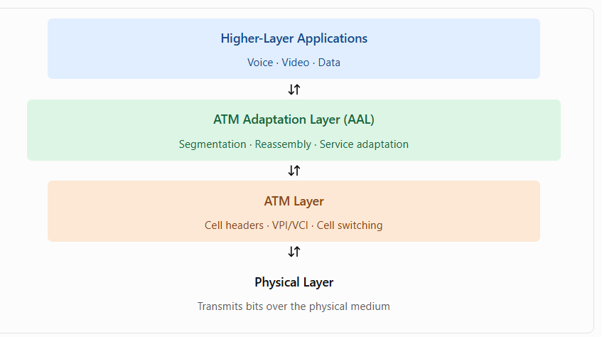

Physical Layer
Transmits bits over the physical medium

Role of ATM Layer in ATM Networks
The ATM Layer (Asynchronous Transfer Mode Layer) is responsible for transferring fixed-size ATM cells from a source to a destination through an ATM network.
It lies between the ATM Adaptation Layer (AAL) and the Physical Layer.
Its main job is to add and process cell headers, identify virtual connections, and switch cells through the network.

2. Main functions of the ATM Layer
1. Cell multiplexing and demultiplexing
Combines cells from multiple virtual connections for transmission over a common physical link and separates them at the receiving side.
2. Cell switching and routing
Forwards cells through ATM switches according to their virtual connection identifiers, VPI and VCI.
3. Header generation and processing
Adds the appropriate ATM cell header at the transmitting side and interprets the header at each ATM switch.
4. Virtual connection identification
Uses the Virtual Path Identifier (VPI) and Virtual Channel Identifier (VCI) to identify the logical connection to which a cell belongs.
5. Traffic management
Supports traffic control mechanisms, including congestion-related functions and traffic parameters associated with virtual connections.
6. Cell loss priority
Uses the Cell Loss Priority (CLP) field to indicate whether a cell has lower priority and may be discarded preferentially during congestion.

Main functions of AAL
1. Segmentation and Reassembly (SAR)
- Segmentation: Divides large data units into smaller pieces that fit into ATM cell payloads.
- Reassembly: Combines the received pieces to reconstruct the original data.
For example, a large data packet must be divided into multiple cell payloads of at most 48 bytes each.
2. Service adaptation
AAL accommodates different application requirements, such as real-time voice, video, and data transfer.
3. Timing support
Certain AAL services support timing relationships needed for applications such as voice and video.
4. Error detection and handling
Depending on the AAL type, additional information can help detect errors or support recovery of the transmitted data.
5. Message boundary handling
AAL may help identify the beginning and end of a higher-layer data unit so the receiver can reconstruct it correctly.

Sublayers of AAL
AAL is commonly divided into two sublayers.
Convergence Sublayer (CS) : Adapts the higher-layer application's data and service requirements. Its functions depend on the AAL type.
Segmentation and Reassembly Sublayer (SAR) : Divides data into cell-sized payloads at the sender and reassembles the pieces at the receiver.

Types of ATM Adaptation Layer
AAL type | Main application | Key characteristic
AAL1 | Constant-bit-rate services, such as circuit-emulated voice | Supports timing and synchronization
AAL2 | Variable-bit-rate, delay-sensitive traffic, such as compressed voice | Efficiently carries short data units
AAL3/4 | Connection-oriented or connectionless data services | Provides segmentation and additional control information
AAL5 | Data networking, including IP over ATM | Simplified, efficient adaptation for data packets
AAL3 and AAL4 were originally distinct service categories but were combined into AAL3/4. AAL5 became widely used for data communication over ATM.

Example: Sending data through ATM
Suppose a computer needs to send a 100-byte data unit using an ATM adaptation method that places the data into 48-byte payloads.
- Cell 1 carries 48 bytes.
- Cell 2 carries 48 bytes.
- Cell 3 carries the remaining 4 bytes, along with any required adaptation information or padding.
Thus, 3 ATM cells are needed for the 100-byte data unit in this simplified example. The exact framing and overhead depend on the AAL type.

ATM cell format
An ATM cell contains 53 bytes in total.

5 bytes Header
Header contains fields such as VPI, VCI, Payload Type Indicator (PTI), CLP, and Header Error Control (HEC). Their exact arrangement depends on whether the interface is UNI or NNI.

48 bytes : Payload

Example of ATM cell switching
Suppose a cell arrives at an ATM switch with the following identifiers:
- VPI = 10
- VCI = 25
The switch examines these identifiers, consults its switching table, and forwards the cell on the appropriate outgoing link. The outgoing VPI and VCI may be different.
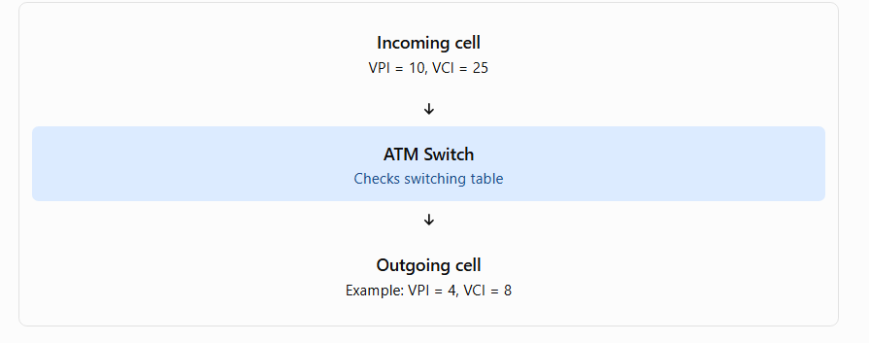
The identifiers shown are illustrative. The switch forwards the cell using the connection mapping established for that link.

Difference between AAL and ATM Layer
ATM Adaptation Layer (AAL) | ATM Layer
Adapts application data to ATM transport | Transfers and switches ATM cells
Performs segmentation and reassembly | Processes cell headers
Supports service-specific requirements | Uses VPI/VCI for virtual connection switching
Works with higher-layer data units | Works with fixed-size ATM cells

ATM network management,
Interfaces M1, M2, M3, M4 and M5 are used in the Telecommunications Management Network (TMN) framework to describe management relationships between network elements and management systems.
They help organize how ATM network components are monitored, configured, and managed.

Basic concept
ATM network management may involve several types of components:
- NE (Network Element): An ATM switch or other network device.
- EMS (Element Management System): Manages a particular network element or a group of elements.
- NMS (Network Management System): Manages the network as a whole.
- Service Management System: Manages services provided to customers.
The M interfaces define management communication relationships between these components. The exact terminology and interface scope depend on the TMN reference model and the ATM management specification being studied.

Five ATM management interfaces
The ATM Forum management reference architecture defines these five interfaces.
Interface | Connection between | Main function
M1 | Private Network Manager and ATM end-user device | Manages end devices, such as ATM terminals or network equipment
M2 | Private Network Manager and private ATM network | Manages private ATM switches and networks
M3 | Private Network Manager and public Network Manager | Enables customer monitoring and management of its portion of a public ATM network
M4 | Public Network Manager and public ATM network | Manages public ATM network elements and network resources
M5 | Two public Network Managers | Supports management information exchange between different public network providers

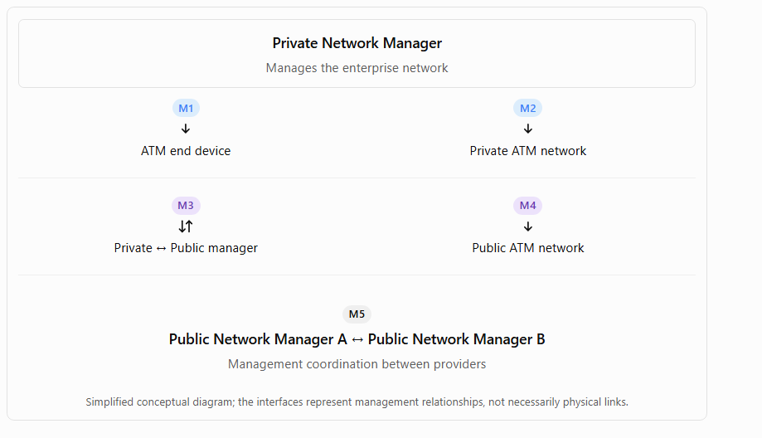

Example to remember
Imagine a company uses its own ATM network equipment and buys connectivity from a public telecom provider.
- M1: Manage the company's ATM end device.
- M2: Manage the company's private ATM switches.
- M3: Allow the company to monitor its contracted portion of the provider's network.
- M4: Allow the provider to manage its public ATM network.
- M5: Allow two providers to exchange network-management information.

